Week of  April 27-May 1 | BIRDS | LINKS
SUMMARY | These are just some of the concepts kids can learn about during a birds:  - What do you know about birds?  - Feathers  - Nests / Eggs  - Bird Sounds  - Identification  - Migration / Seasonal Changes |  | 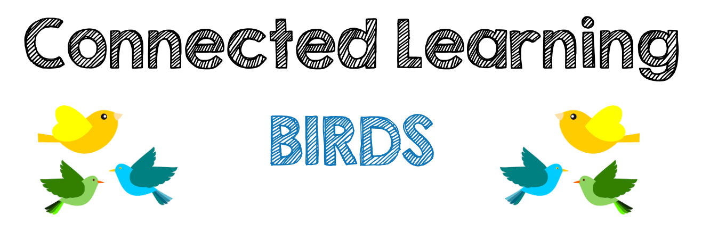
PINTEREST PAGE | https://www.pinterest.com/kmorrow0798/tremendous-trees/
BIRD BRAINSTORM | What do you know about birds?  Pose this question to your children to learn about the importance of birds on our environment. |  | - What is the importance of a bird’s feathers?  - Why do birds hav beaks of different shapes and sizes?  - Why to birds make different types of nests?  - Listen to the birds - how many different birds to you hear?  - Why do some birds migrate to different locations during seasons?
TAKE HOME ACTIVITIES | 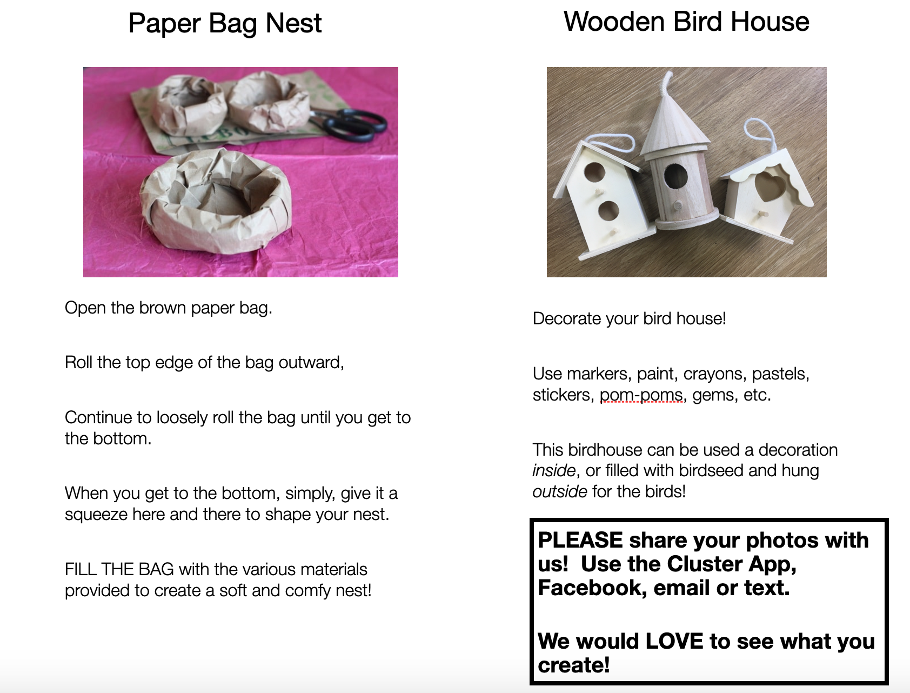 | IN THE BIN ON THE LOWER PLAYGROUND | 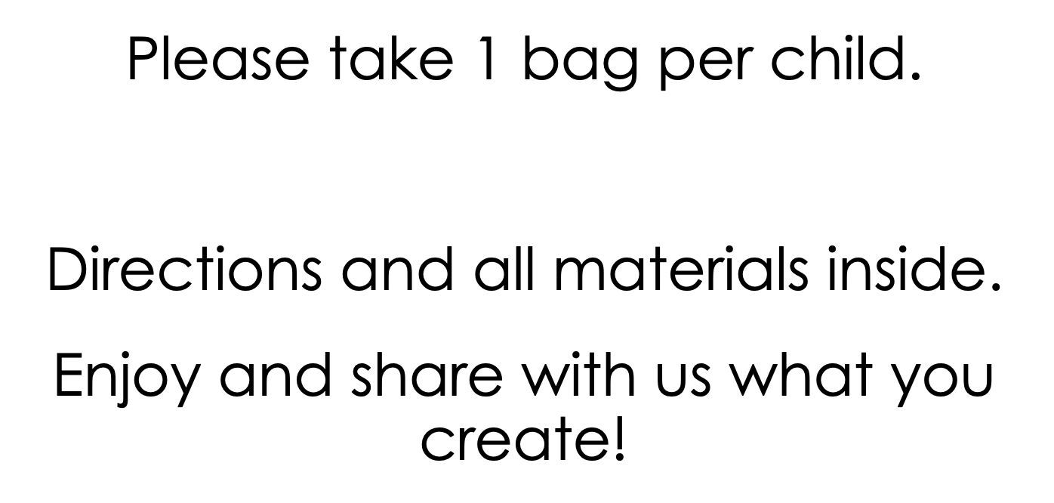
Baby Birds in Next Video | Sweet Video showing eggs that hatch! About 10 minutes in length and set to relaxing music. A joy to watch!! | https://www.youtube.com/watch?v=6J-30wSZtbE | 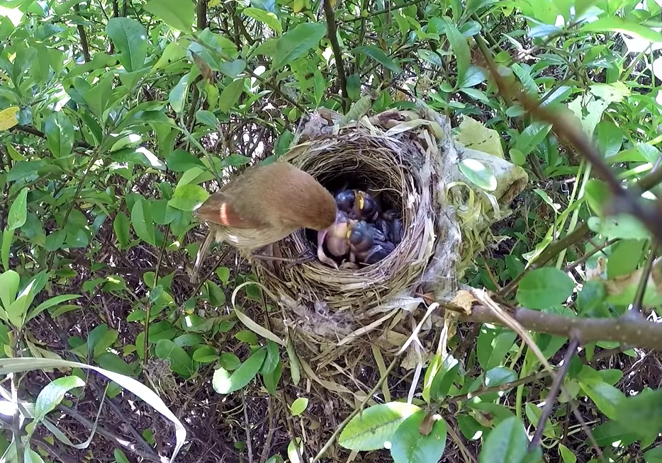
Snack Idea | Pretend you are a little bird. Use a pair of tongs to represent your beak and use to pick up your snack. Foods such as berries and cereal, that are small and bite-sized. |  | 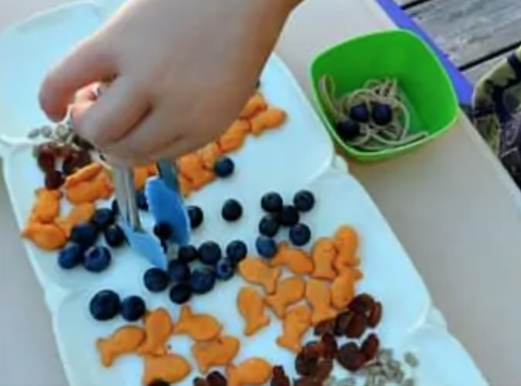
Book/Literature | This Is the Nest That Robin Built | https://www.youtube.com/watch?v=C9prIh2EFWc | 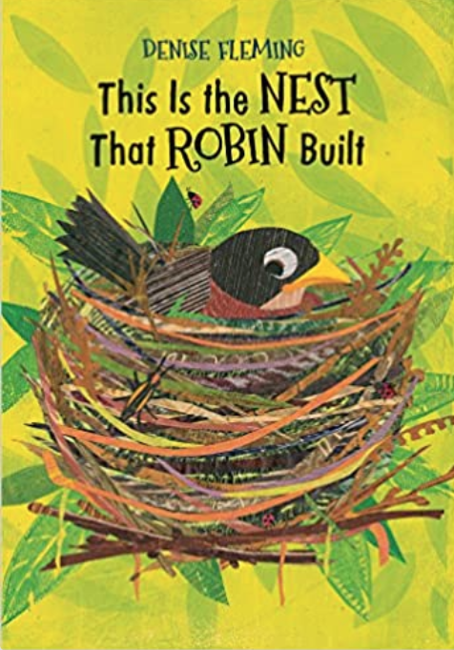
Book/Literature | Have You Heard The Nesting Bird? | https://www.youtube.com/watch?v=ka38tL5MS4U | 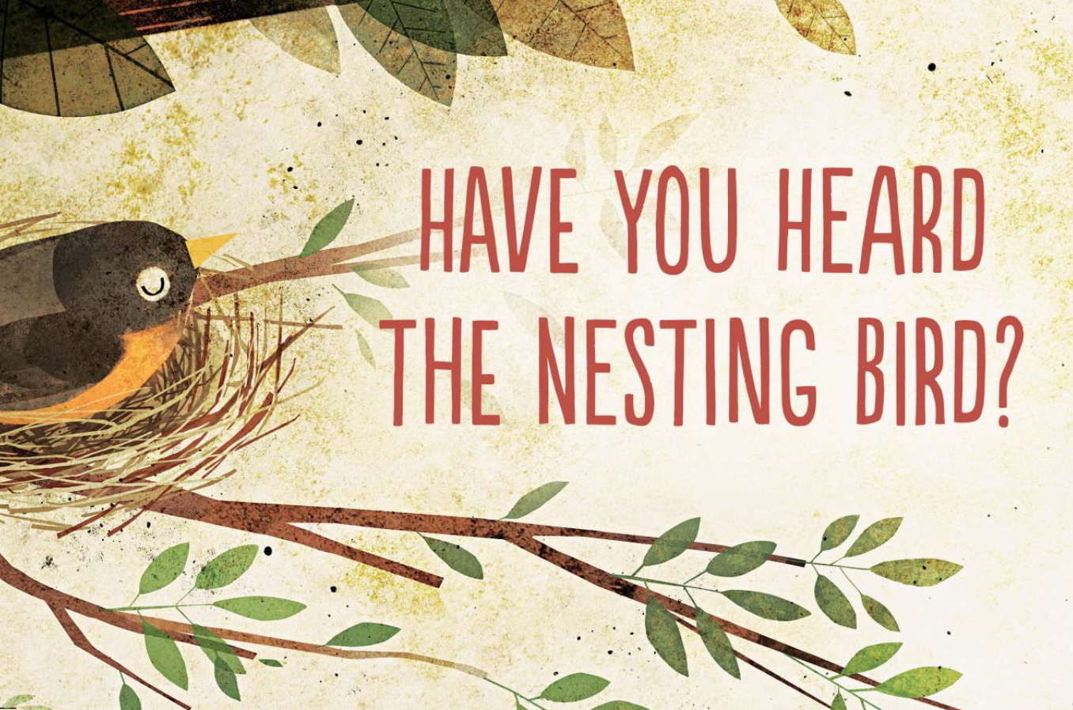
Book/Literature | Whose Nest? | https://www.youtube.com/watch?v=yBJx-eoCsCE | 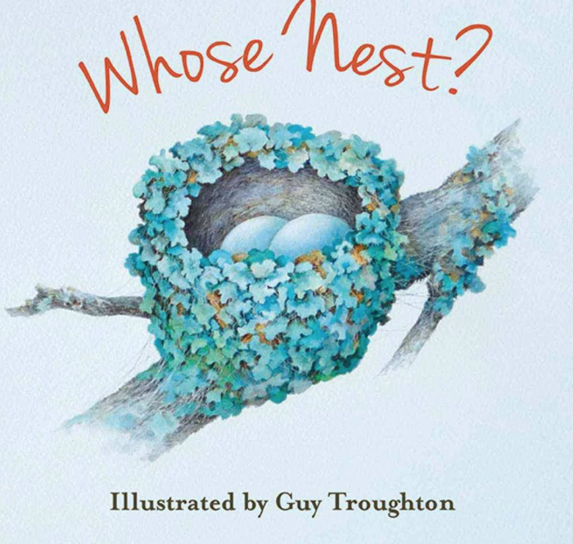
Book/Literature | A Nest Full of Eggs: Bedtime Stories | https://www.youtube.com/watch?v=EiM1lPrlElY | 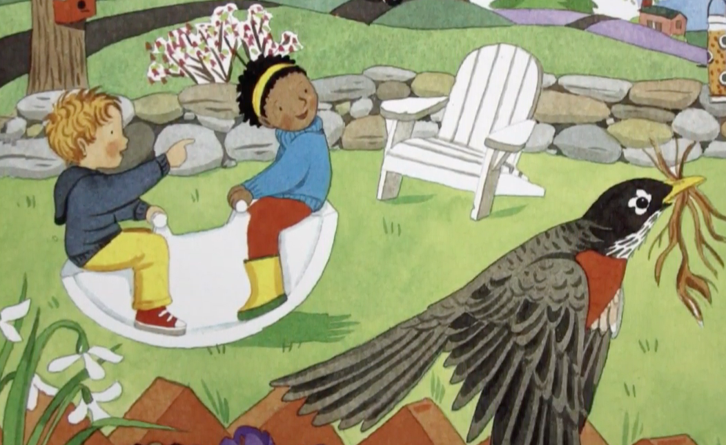
Book/Literature | Feathers for Lunch | https://www.youtube.com/watch?v=8fmsD-LFQmA | 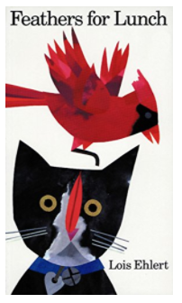
Book/Literature | An Egg is Quiet | https://www.youtube.com/watch?v=KgVaNbrCayU | 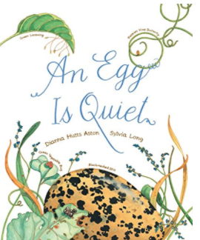
Book/Literature | Nest | Board Book | 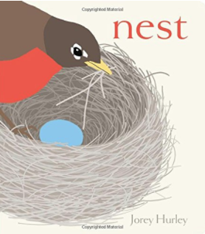
Book/Literature | Mama Built A Little Nest | https://www.youtube.com/watch?v=f0nEJ_f5pVg | 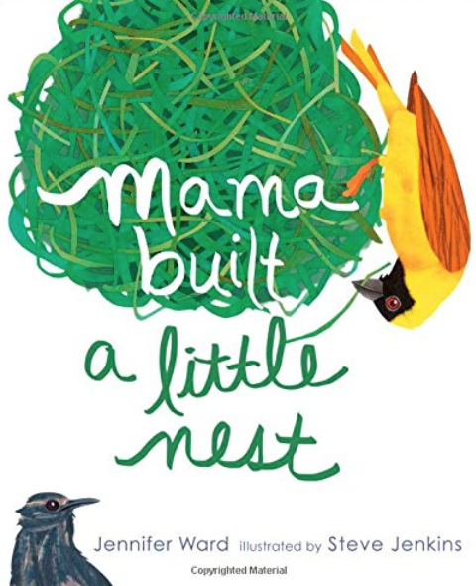
Book/Literature | Birds Make Nests | https://www.youtube.com/watch?v=PWpKj7LQeHY | 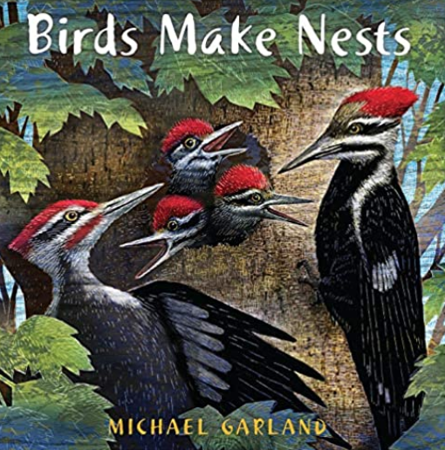
Book/Literature | Bird Builds a Nest | https://www.youtube.com/watch?v=AiBIMl9ASkk | 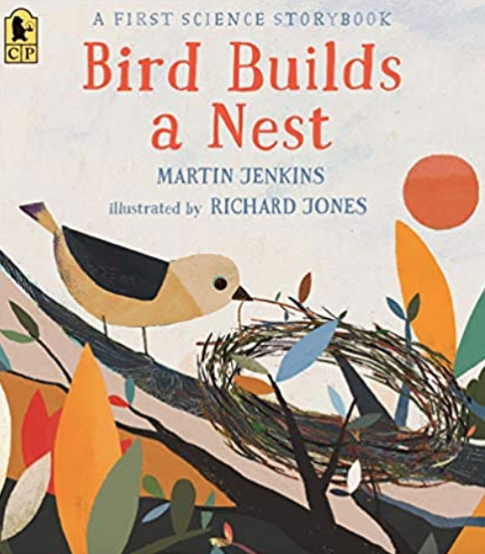
Book/Literature | A Nest Is Noisy | https://www.youtube.com/watch?v=xAagI_LeS9Y | 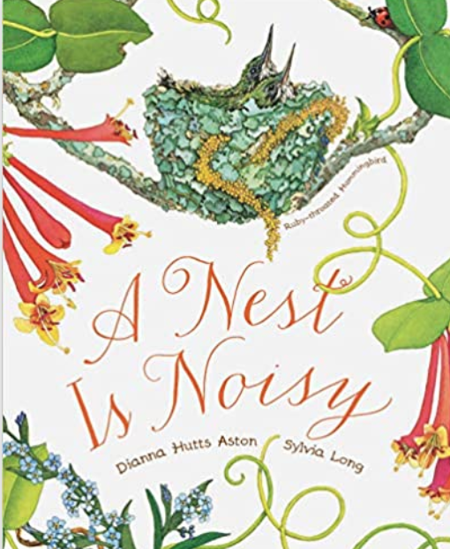
Book/Literature | Shake a Leg, Egg! | https://www.youtube.com/watch?v=-ajmFMalmmQ | 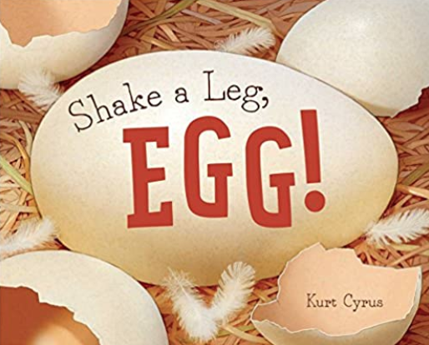
Book/Literature | My Happy Year |  | 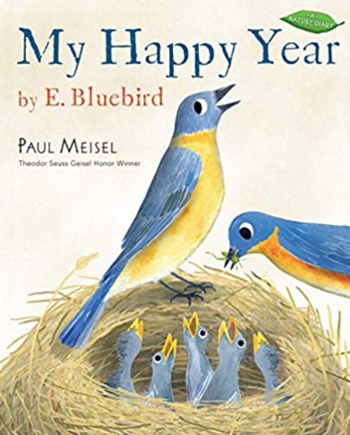
Book/Literature | Tree of Birds | https://www.youtube.com/watch?v=0zXin02Rgrc
Book/Literature | Birds | https://www.youtube.com/watch?v=8Xrti-oaJHI
Math | Number Identification  Use remaining plastic eggs. Write numbers in eggs and hide. Have your child identify the numbers. For an extension and challenge, have them put the numbers in order from least to greatest, add and subtract (can use candy or cereal as a counter / manipulative to aid in process.
Science | Observation and Identification  Make your own set if binoculars to observe the birds!  Glue 2 toilet paper rolls together. Decorate with yard and make a loop for around their neck.  Identify what different types of birds you see! |  | 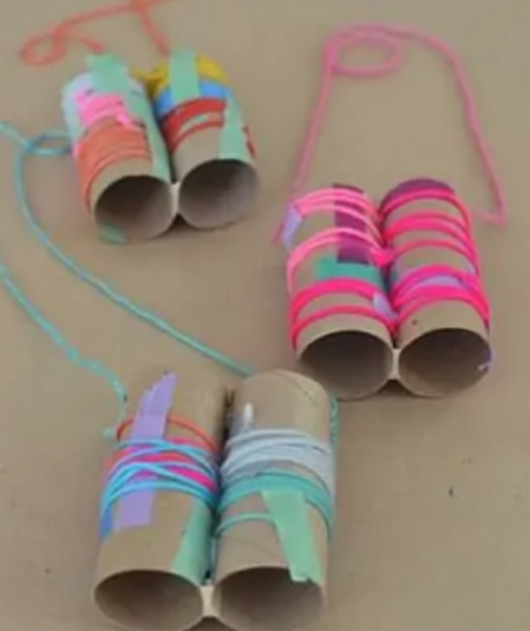
Science | Bird Sound Listening Activity  Print Bird Photo Cards  Arrange the photo cards on the floor, table or pocket chart.  Use this site to play bird sounds:  The child listens to the sound and selects the photo of the bird he or she thinks makes the sound.  Repeat! | http://soundbible.com/tags-bird.html | 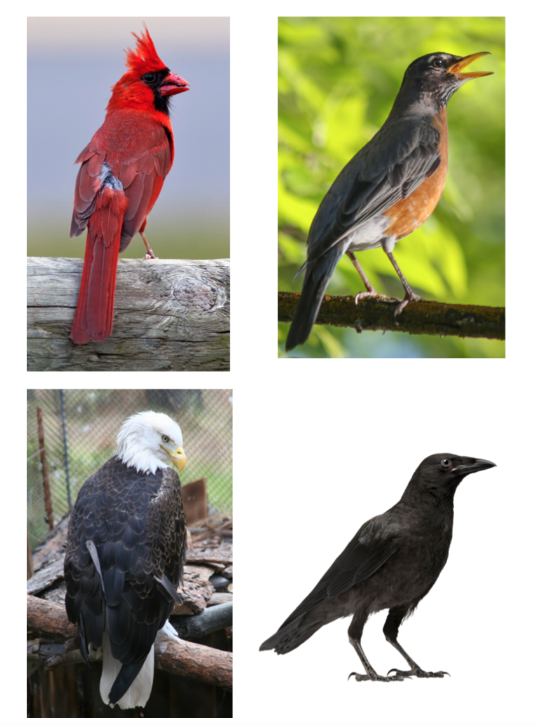
Science | Backyard Bird Bingo | Attached  Printable  Resources | 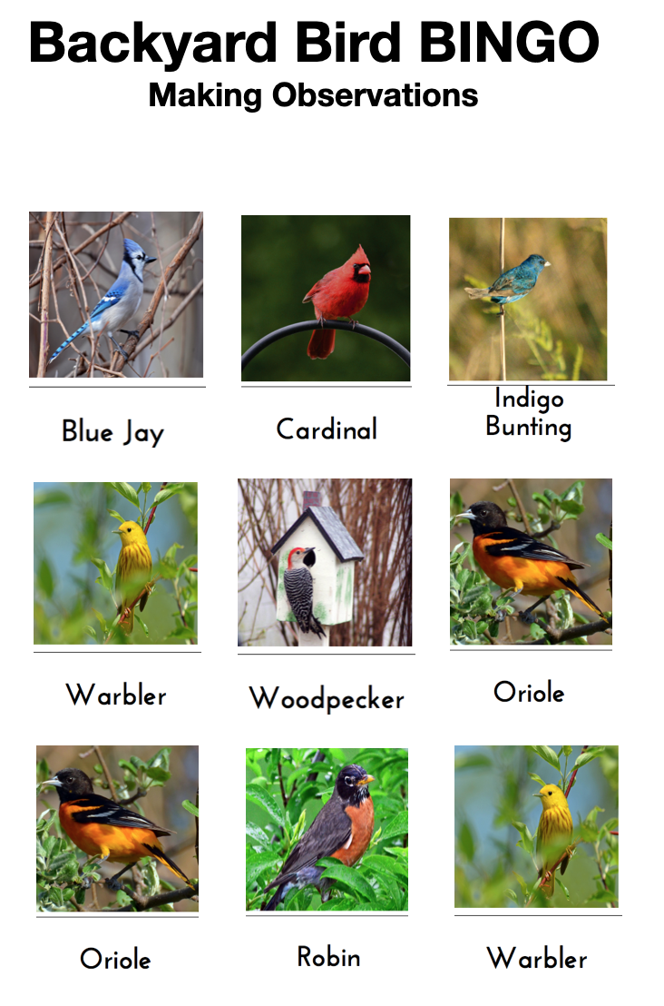
Science | Chesapeake Conservancy Peregrine Falcon Cam powered by EXPLORE.org  This peregrine falcon family makes its home in an unlikely place: a skyscraper in downtown Baltimore. Watch live and learn more about these adaptable birds of prey on Explore.org | https://www.youtube.com/watch?v=pDzgu0ihW8g | 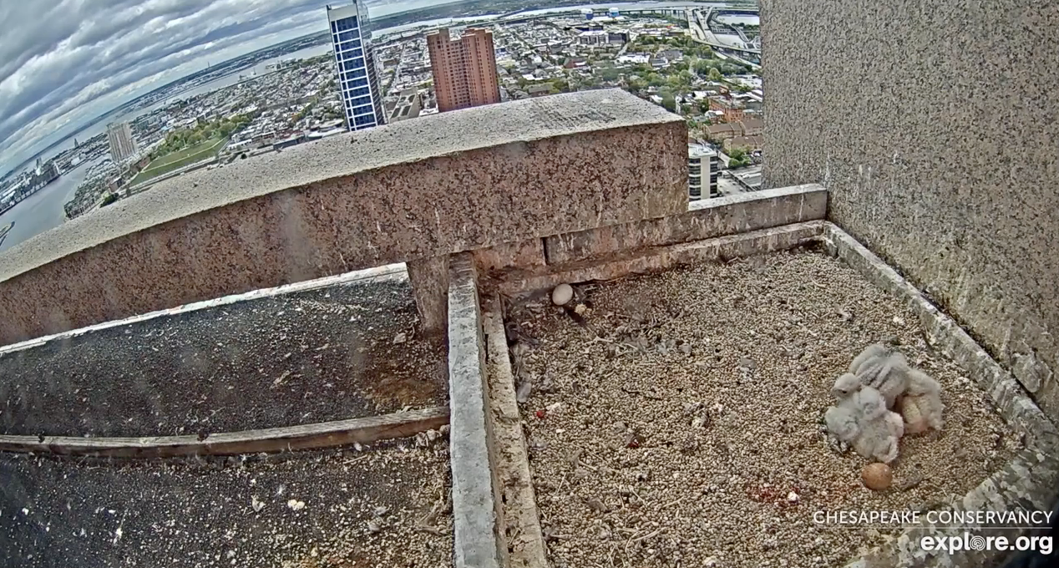
Science | Bird Beaks. Create a bucket of "bird food". Then provide each student with a beak tool, like tongs, chopsticks, eye droppers, forks, pliers, tweezers, toothpicks, & clothespins. They should try to gather as much food as they can. | https://www.pinterest.com/pin/135600638765233106/ | 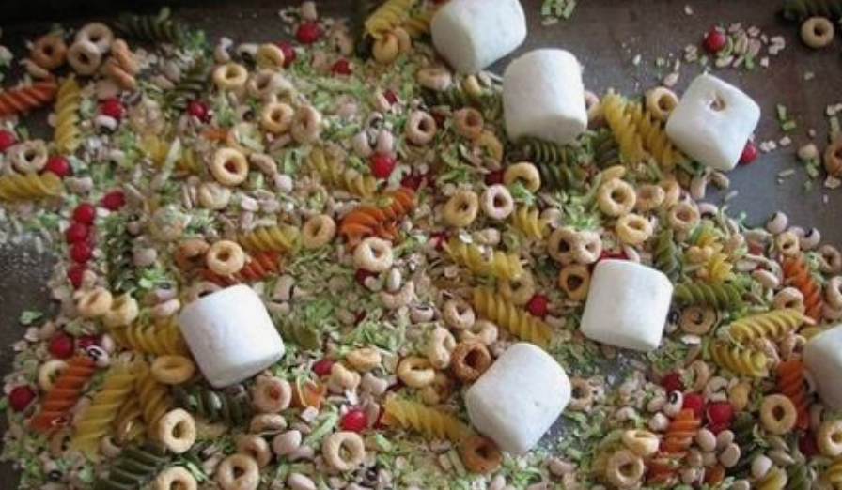
Bird Feeder | Milk Carton Bird Feeder  Small milk carton (the kind at school)  non-toxic poster paints  stapler and staples  hole punch  yarn or string  1. Wash and thoroughly dry the milk carton.  2. Cut a small section from the carton and then staple the top opening closed.  3. Paint the container, if desired. Let it dry. (Note: If you paint the feeders in streaks of tan, gray and brown they will resemble tree bark. Then, on the bottom, paint on dark and light green leaves. When you stand underneath the hanging bird feeder, it really blends in with the canopy of leaves above it!)  4. Poke a hole in the middle of the top of the carton, and thread a piece of yarn or string through it to use as a hanger. (The string should be long enough for the feeder to hang where the branches don’t rub against, but not so long that the feeder hangs too far away from the tree’s leaf cover. Birds like to feel they have a hiding place to fly into quickly!)  5. Add birdseed and hang the feeder. (Since the small milk carton feeders are just the right size for the tiny birds such as finches, wrens, etc., you might want to use thistle seed. It is the finch’s favorite food! Garden supply stores carry a sterile thistle seed just for bird feeding which is guaranteed not to sprout all over the yard). | This bird feeder won’t last long, but it is so easy to make, you can always have another one made all ready to replace it when it wears out! | 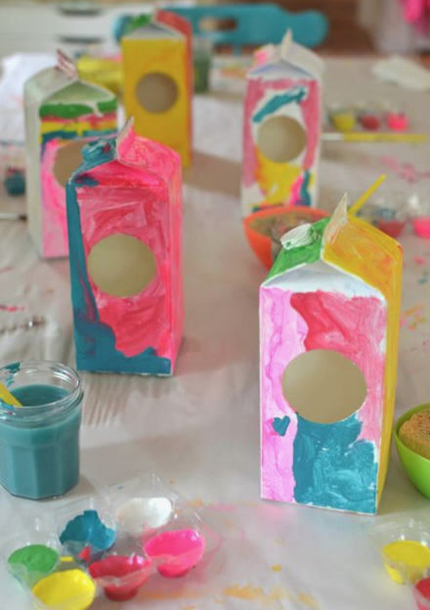
Bird Feeders | Plastic Bottle Bird Feeders  Punch holes on either side of a plastic pop bottle.  Stick a twig all the way through with its ends sticking out for perches; poke more holes nearby for the birds to pull the seeds out.  Hang the bottle by tying a string around its neck.  (Finches really like these.) |  | 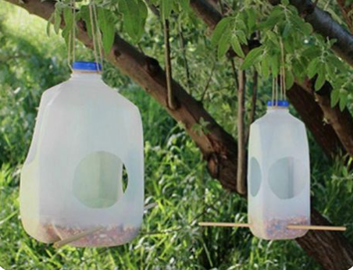
Bird Feeder | Pine Cone Bird Feeder  Lard or peanut butter, String, Pine cone, Birdseed  1. Tie a piece of string around the widest part of the cone.  2. Mix the lard and seed together.  3. Press the mixture into the branches of the cone.  4. Use the string to tie the cone up in a tree pr bush for the birds to enjoy. |  | 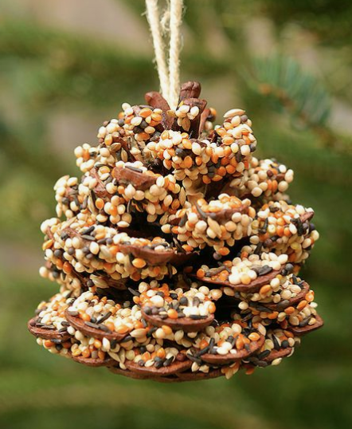
Art | Feather Painting  Put out an assortment of feathers, paper and paint.  Have children experiment with a variety of paint textures and feathers for their own unique piece of “Feather Art“. | https://www.pinterest.com/pin/190980840436672883/ | 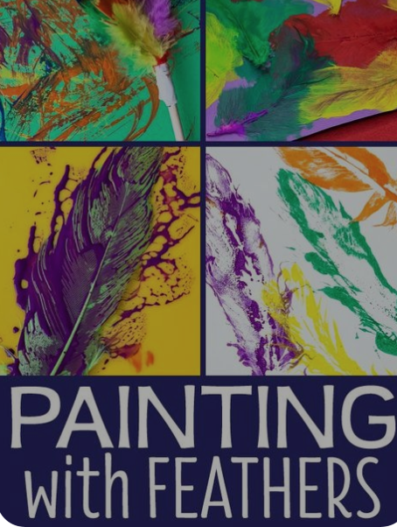
Art | Birdseed Collage:  Materials: Birdseed, plain paper or picture of a bird (colored by child or not), glue  Have children apply glue and then bird seed to their name (written out in glue) or a picture or paper in design of choice. For interest, use a variety of bird, sunflower, corn kernels, etc. |  | 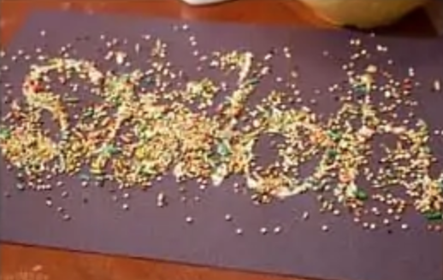
Art | Draw a Bird: Video Instructions on how to draw a Triangle and Circle Bird | https://www.youtube.com/watch?v=J9pZ_GIL_Yc | 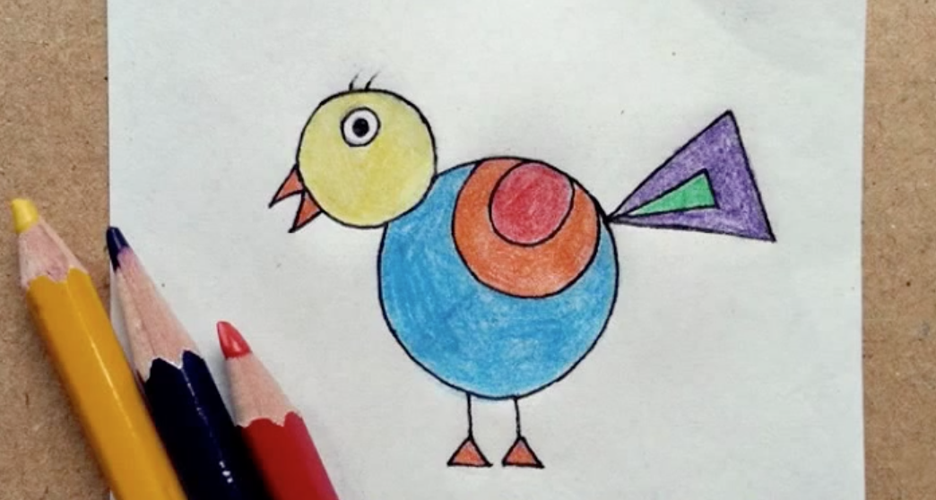
Art | Simple Bird Kites | https://www.pinterest.com/pin/759701030871998267/ | 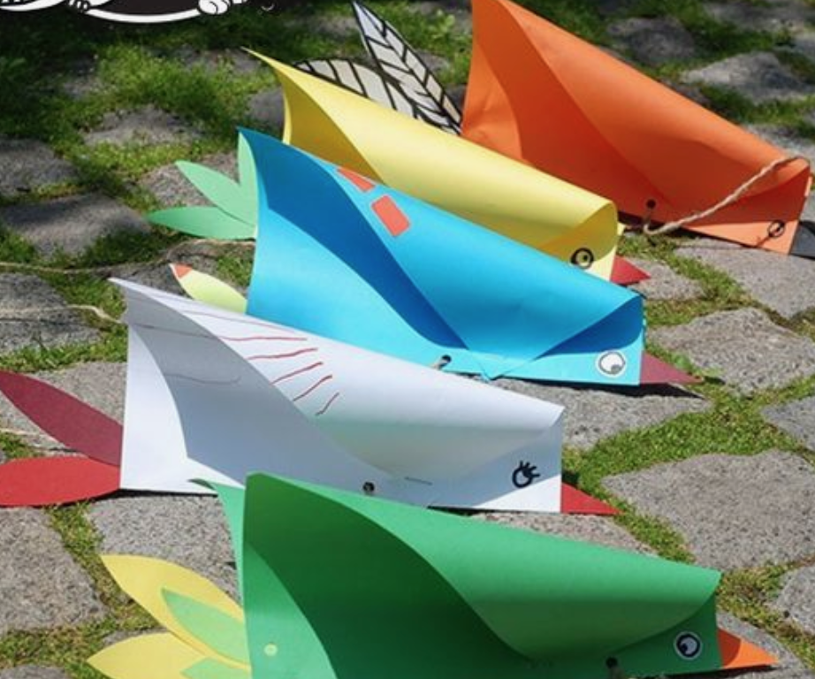
Music | Mrs. Sherry has recorded some songs about BIRDS!!  Click on the link and sing along! | https://share.icloud.com/photos/0KWfbp1tz-14-MkAK9Zqfw2TQ#Baltimore | 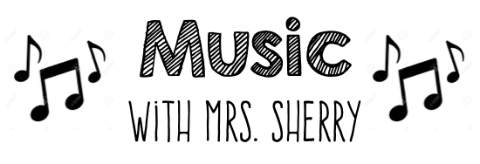
YOGA | Birds Fly South - YOGA | https://www.youtube.com/watch?v=rIRLsof5jHM | 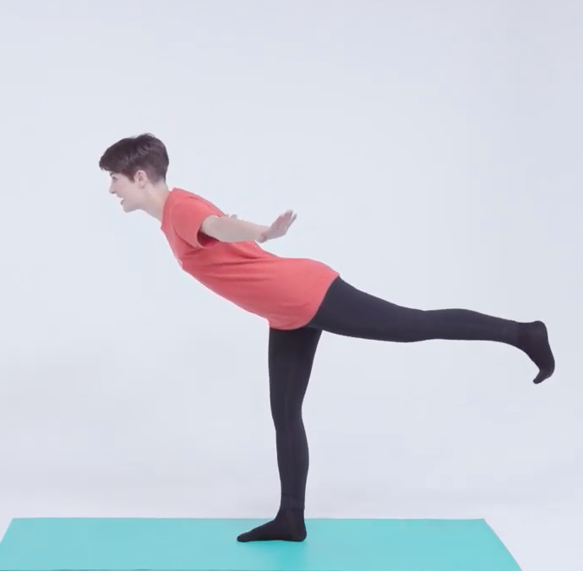
Fine Motor | Birdseed Play Dough  Birdseed  2 cups flour  1 cup salt  Water  Mix flour, salt & birdseed with sufficient water to make play dough texture.  Note: This activity is included because it contains “bird seed” and fun to the theme. Do not place outdoors when done playing–as salt is dangerous to birds. It can make them ill–or kill them if consumed in large quantity. |  | 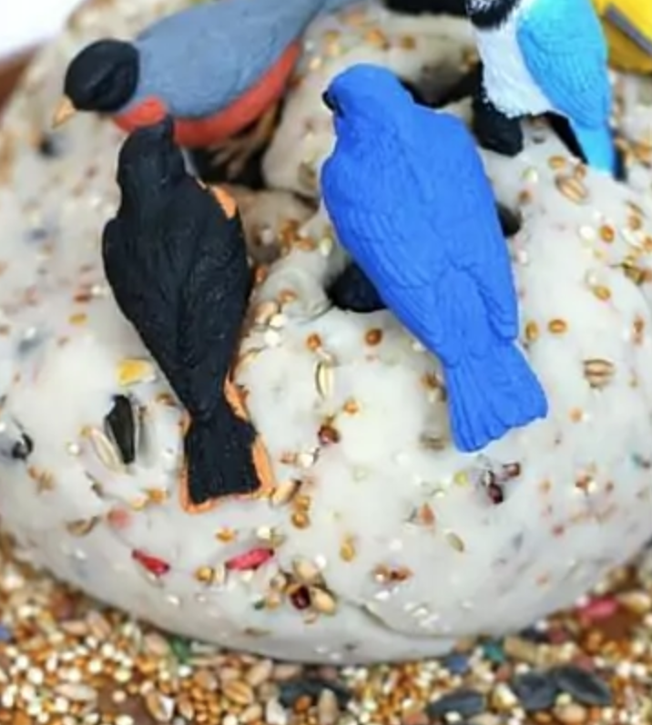
YOGA | Bird Yoga for Kids  hawk, hummingbird, woodpecker, and quail | PRINT  from Resources | 