Week of  April 13 - 17 | Tremendous Trees | LINKS
SUMMARY | These are just some of the concepts kids can learn about during a tree theme:  - parts of a tree and what each part does  - trees as animal homes and habitats  - Seasonal changes of tress  - coniferous and deciduous  - Leaves | Preschool Tree Theme Activity Page  https://www.fantasticfunandlearning.com/tree-theme-preschool-activities.html | Trees are all around us. They come in many different shapes, sizes, and even colors. Some remain green throughout the year, while others have leaves that change colors and fall to the ground. Tree theme preschool activities can be a fun topic to explore year round. Here are some fabulous resources for planning your preschool tree theme. Most of these activities are designed for kids ages 3 through 5, but many can be modified for younger and older kids as well.
PINTEREST PAGE | https://www.pinterest.com/kmorrow0798/tremendous-trees/ |  | 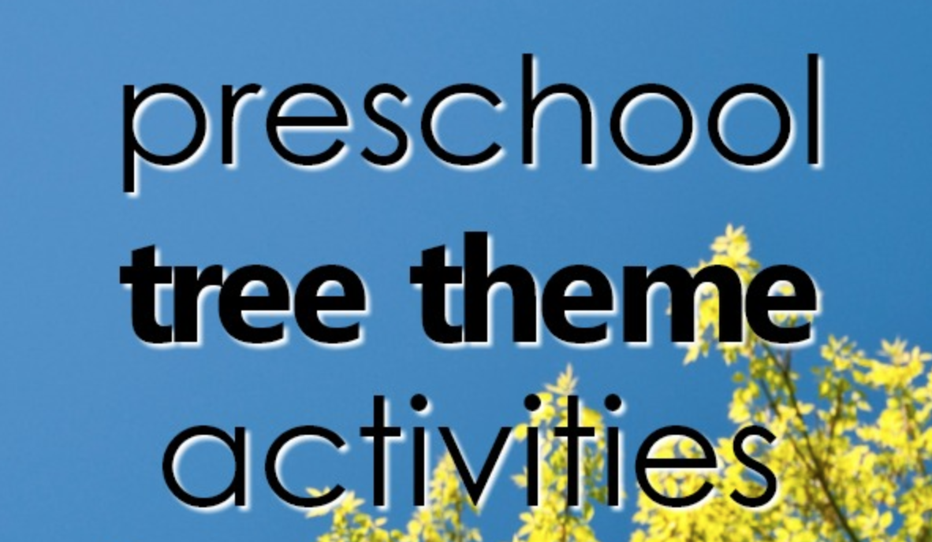
TREE BRAINSTORM | What do we get from tree?  Pose this question to your children to learn about the importance of trees on our environment and all the things that we get from trees. apples, lemons, oranges, bananas, sap, maple sugar, chocolate, animal homes, paper, money, shade, wood, pencils, rubber, etc. | https://www.pinterest.com/pin/421790321348520254/ | 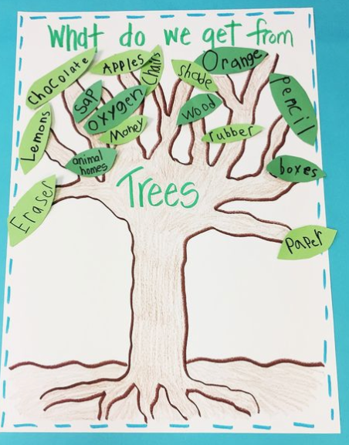
Language / Literature | Maple by Lori Nichols | https://www.youtube.com/watch?v=DJwqKlyWphw
Book/Literature | The Hugging Tree by Jill Neimark | https://www.youtube.com/watch?v=ru09pVHLX6o
Book/Literature | The Busy Tree | https://www.youtube.com/watch?v=3XWm7xdAJzw
Book/Literature | A Grand Old Tree | https://www.youtube.com/watch?v=3mwKqD_GfVY
Book/Literature | Little Tree by Loren Long | https://www.youtube.com/watch?v=CGquWvJH39M
Book/Literature | The Giving Tree by Shel Silverstein | https://www.youtube.com/watch?v=Ybcr1HL7sq0
Book/Literature | A Tree for All Seasons | https://www.youtube.com/watch?v=Z8_pSAS5EGw | 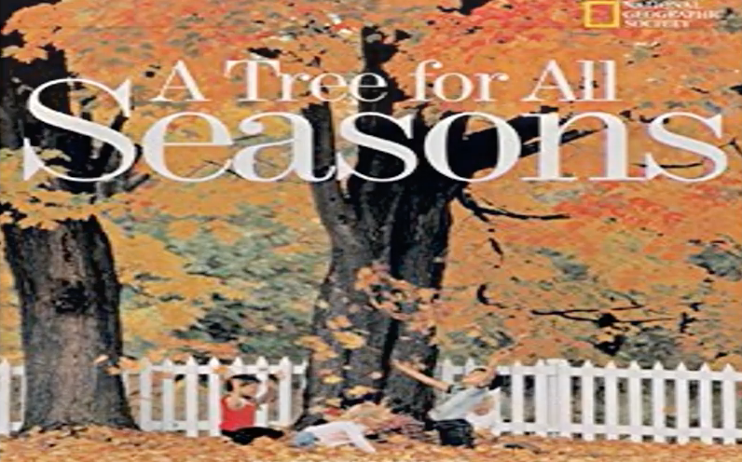
Book/Literature | Are Trees Alive? By Debbie Miller | https://www.youtube.com/watch?v=DPgt15gd8v8
Book/Literature | A Tree Named Steve by Alan Zweibel | https://www.youtube.com/watch?v=Fmj5JIvE9DY
Book/Literature | Because of An Acorn | https://www.youtube.com/watch?v=ZKawcvOE7g4
Book/Literature | Hamilton Duck’s Springtime Story | https://www.youtube.com/watch?v=pINUK8w4Dbo
Nature/Science | Spend some time under a tree, enjoy the shade, and collect items to make Sensory Soup. Combine pine cones, flowers, dirt, sticks and rocks in a bowl of water. After you mix it well, are there items that sink or float? You might be able to find unique items under specific trees that could spark a conversation about what type of tree it is and what it may produce. | https://www.thecrazyoutdoormama.com/sensory-soup-fun-kids-camping-activity/ | 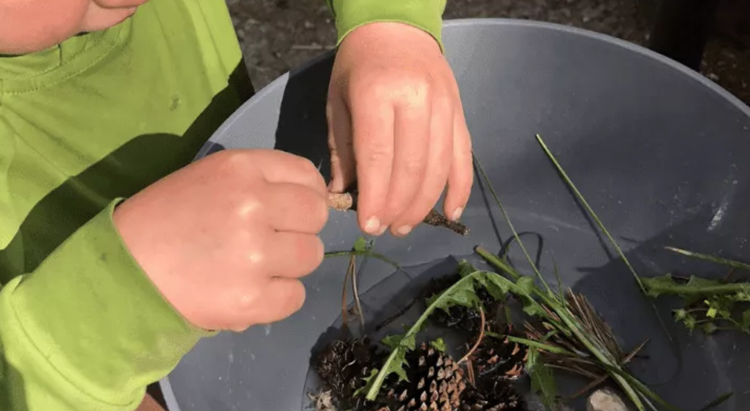
Science | Go on a neighborhood scavenger hunt to collect as many different leaves as you can find. Then match to the chart (link) | https://www.pinterest.com/pin/413064597073622727/ | 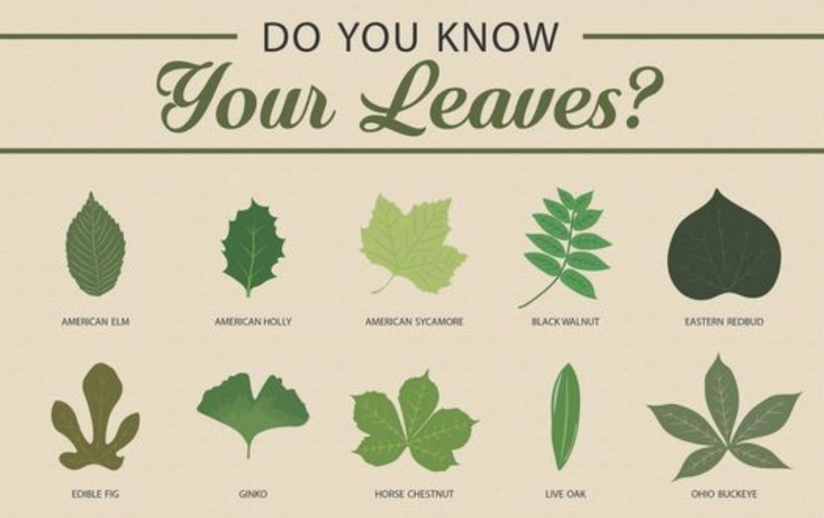
Science | In order to understand how trees get their nutrients from the ground, try an experiment with celery, water and food coloring.The celery sucks up the water just like a tree does from the earth. | https://curiodyssey.org/activities/science-experiments-for-kids/how-to-make-rainbow-celery/ | 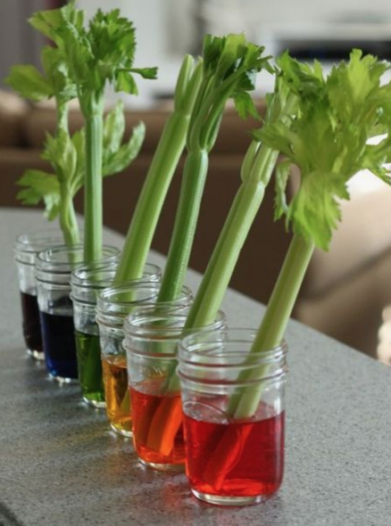
Science | Make a diagram of a TREE: including ROOTS, TRUNK, BRANCHES, AND LEAVES. | https://www.pinterest.com/pin/744360644649666219/ | 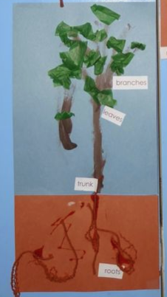
Science | Trees in Different Seasons - Use the provided sheet to draw the tree in different seasons. | https://www.pinterest.com/pin/336362665919992593/
Science | How to Identify a Tree by Its Leaves, Flowers, or Bark  Use this resources to identify items found outside on a Nature Walk. | https://www.pinterest.com/pin/180355160053071215/
Music | Douglas Mountain by Raffi | https://www.youtube.com/watch?v=7nlSk5QRjno | 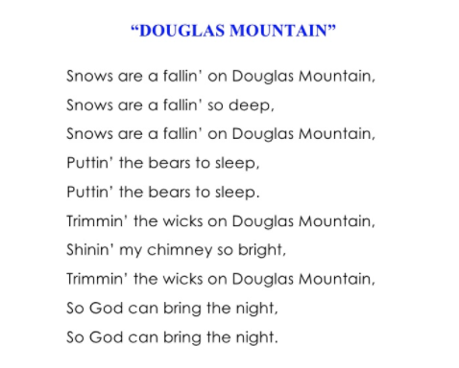
Music | “I’m A Tree” | https://www.youtube.com/watch?v=nCyHRGExDZ0 | 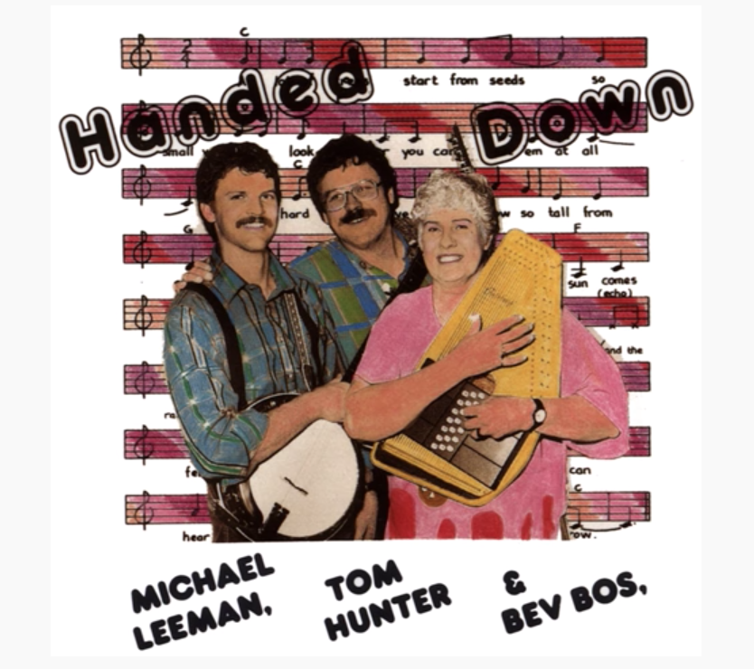
Art | Collect Pine Cones and make a collage or dip in paint and use to make prints. | https://www.pinterest.com/pin/744360644649666202/ | 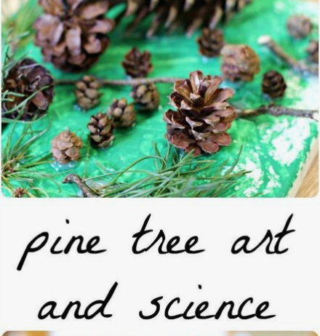
Art | Tree Bark Rubbings - Get paper and crayons (take the paper off the crayons) and look for different types of bark. Some is smooth, others more rough. Place the paper on the bark and rub the side of the crayons over the bark. Compare different types of trees and the markings they make. | https://www.pinterest.com/pin/297730225365692616/ | 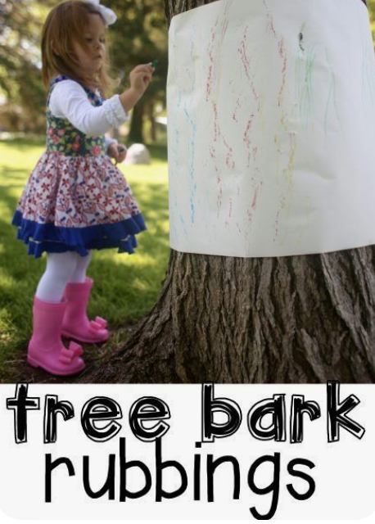
Art | Drawing Tree - Pick a favorite tree in your yard or neighborhood. Tie a string around the truck and attach drawings with clothespins. This can be done over several days and added to by your family and encourage others to do so as well! Just put a sign to have others hang their drawings to share!! | https://www.pinterest.com/pin/657525614321996731/ | 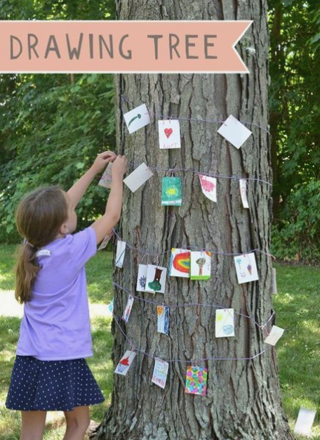
Art | Broccoli Stamped Cherry Blossom | https://www.pinterest.com/pin/164874036346526528/ | 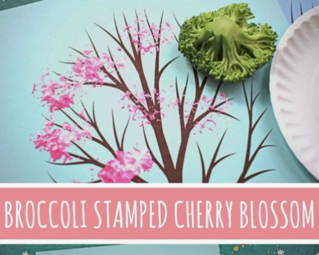
Recipes | Applesauce | https://www.pinterest.com/pin/267823509077835718/ | 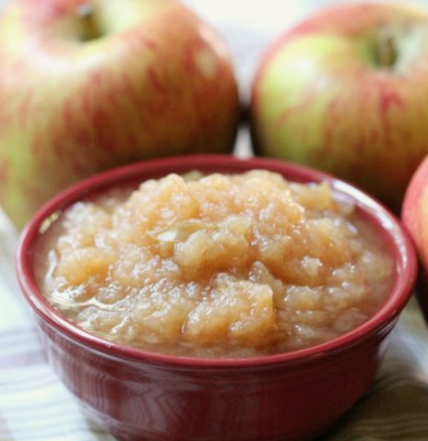
Recipes | Apple Cake | https://www.pinterest.com/pin/223209725268961870/ | 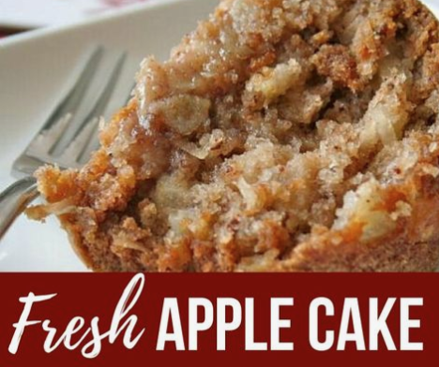
Recipes | Apple Crumble Muffins | https://www.pinterest.com/pin/749638300457541323/ | 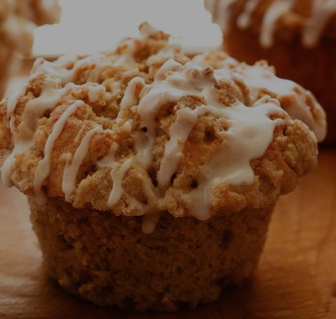
Gross Motor | Game link to the right. Plant the Tree. I don't think you need the cones, just have a boundary line the students must cross to "plant the tree." If you have cones, you can say they must plant the tree under the cone. No beanbags? Use small balls. | https://www.youtube.com/results?search_query=plant+the+trees+game | 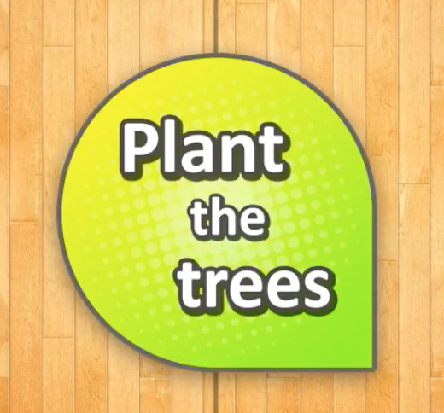
Fine Motor | Snack - Use pretzel sticks for the trunk and branches, and cereal for the leaves. |  | 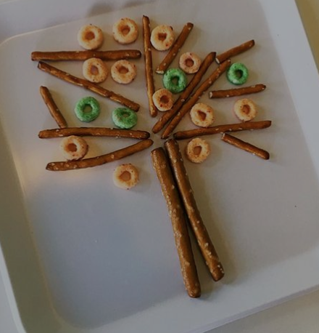
Fine Motor | Decorate a Tree with Loose Parts: pipe cleaners, straw pieces, clothes pins, leaves with a hole punched in it, yarn or string, etc. | https://www.pinterest.com/pin/125749014582836951/ | 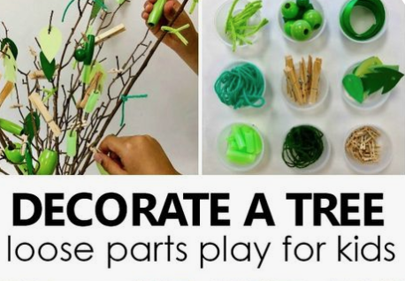
Nature / Art | Collect a variety of leaves, sticks, acorns, pebbles, etc. and made “nature people”. | https://www.pinterest.com/pin/288089707396286370/ | 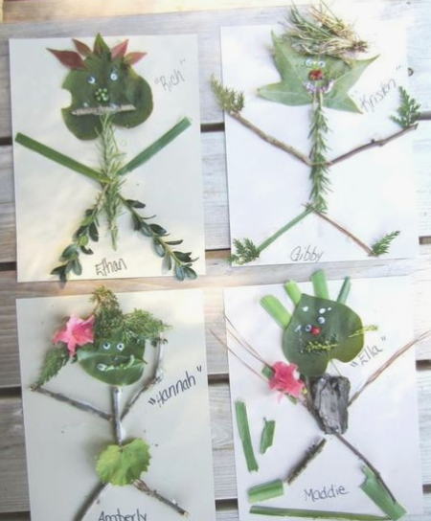
Nature/Science/Art | Begin exploring a favorite tree by observing its shadow. Your child can compare their shadow to the trees and play around with how to make their shadow look more like a tree. (Maybe by doing the "tree" pose in yoga?) If you have a large piece of paper or unused wrapping paper, you could also trace part of the tree's shadow. | https://creativebynature.org/light-and-shadow/#top | 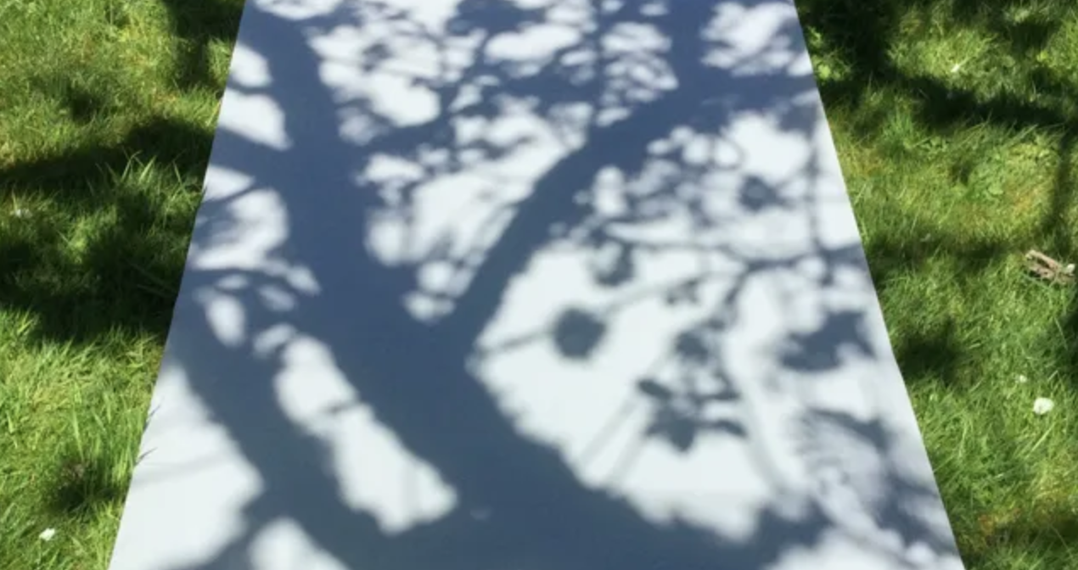
Nature/Colors | This color wheel is a great way to begin an exploration of trees. Have the children hold the color wheel up to different trees and observe what colors they can find. Spring in Maryland is beautiful. I not only see the brown of the bark and the green of the leaves, but I see pink and yellow blooms, red leaves, etc. If you can not print the color wheel it would be fun to make your own with crayons or markers. After making observations, sit outside with paper and pencils or crayons and draw a beautiful tree. | https://mothernatured.com/printables/nature-color-wheel-printable/ | 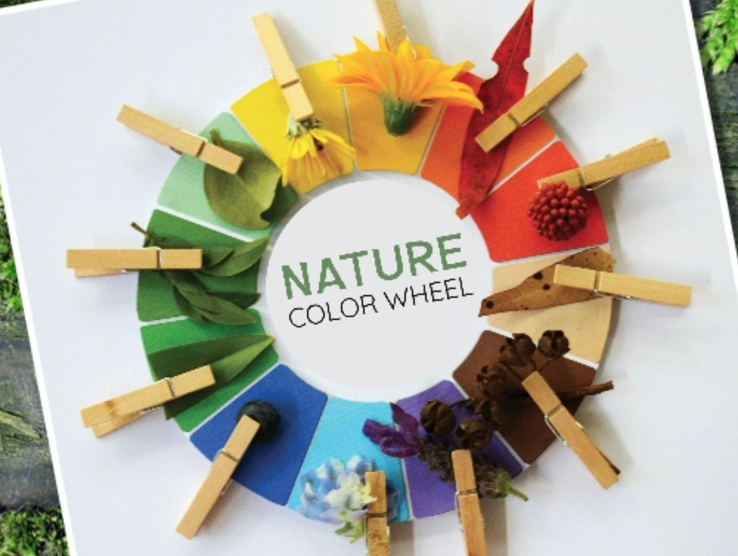
Gross Motor Skills | Some of the children know this yoga pose well, the "tree" pose. Below is a pose they can try in addition to the the "tree" pose, the "falling leaf" pose. | https://www.flowandgrowkidsyoga.com/blogs/news/yoga-poses-for-kids-tree-pose | 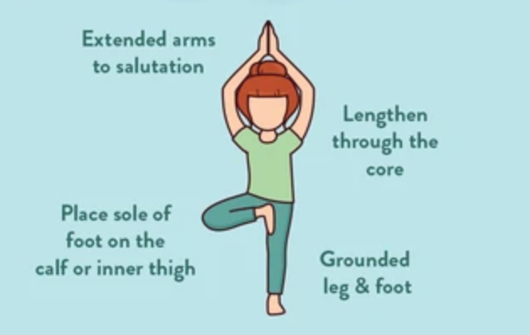
YOGA |  | https://www.flowandgrowkidsyoga.com/blogs/news/yoga-poses-for-kids-falling-leaf-pose | 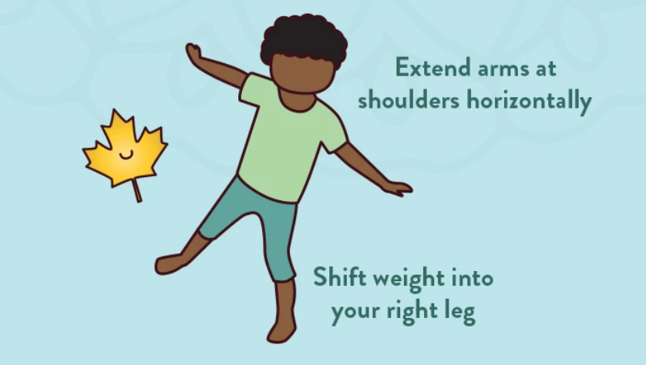

Tremendous Trees
Curriculum - April 13-17th

