|  |  |
| --- | --- |
|  | **From Mrs. Kusner…. A FAVORITE!!!** |
| **Check out this link from Mrs. Sherry with SONGS to sing along at home!** |  |
| <https://share.icloud.com/photos/0a1DVn6dhASdCVF8LOh6KqA6Q#Baltimore> | BABY SHARK SONG:  <https://www.youtube.com/watch?v=FX20kcp7j5c> |

|  |  |  |  |
| --- | --- | --- | --- |
| **Week of**  **May 4 - 8** | **WEATHER** | **LINKS** |  |
| **SUMMARY** | These are just some of the concepts kids can learn about WEATHER:   * What is weather? * What causes weather? * How do we track weather? * What is climate? * How does the change in weather affect us? |  |  |
| **PINTEREST PAGE** | <https://www.pinterest.com/kmorrow0798/weather/> |  | pasted-image.tiff |
| **WEATHER BRAINSTORM** | What do you know about weather?  Pose this question to your children to learn about the importance of how and when the weather changes in our environment. |  | * What are different types of weather? * Why it is important to be able to predict the weather? * Why to birds make different types of nests? * Listen to the birds - how many different birds to you hear? * Why do some birds migrate to different locations during seasons? |
| **Books / Literature** | The Cloud Book by Tomie dePaola | <https://www.youtube.com/watch?v=eS5uN0RuIHI> |  |
| **Books / Literature** | Little Cloud by Eric Carle | https://www.youtube.com/watch?v=WhUI7V-JbSI |  |

Connected

Learning

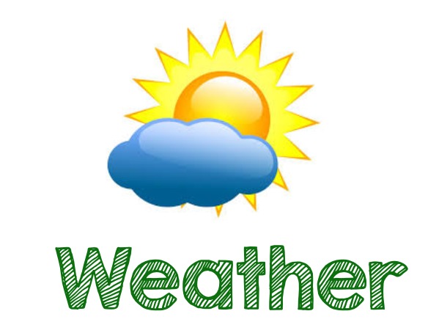

|  |  |  |  |
| --- | --- | --- | --- |
| **Books / Literature** | The Weather Girls by Aki | <https://youtu.be/N63kBjKs7O0> |  |
| **Books / Literature** | The Rain Came Down by David Shannon | <https://youtu.be/NRAE_lx5GAo> |  |
| **Books / Literature** | Wind by Marion Dane Bauer | <https://youtu.be/hfSGuSNrOeM> |  |
| **Books / Literature** | Sun by Sam Usher | <https://youtu.be/94Ku-fr6D68> |  |
| **Books / Literature** | The Rainy Day by Anna Milboure and Sarah Gill | <https://youtu.be/av2FP2n2qrg> |  |
| **Books / Literature** | Tap Tap Boom Boom by Elizabeth Bluemle | <https://youtu.be/gwVynyf9jSs> |  |

|  |  |  |  |
| --- | --- | --- | --- |
| **Books / Literature** | Hello World Weather by Jill McDonald | <https://youtu.be/eM2Py8EeML4> |  |
| **Books / Literature** | The Snowy Day by Ezra Jack Keats | https://www.youtube.com/watch?v=FmZCQfeWjeQ |  |
| **Phonics** | **Cloud Writing**  Use shaving cream to make ‘clouds’ and write letters / names in the clouds! | https://www.pinterest.com/pin/686869380657880527/ |  |
| **Phonics** | **Name Cloud Mobile**  Write your child’s name in the cloud, and have them write the letters on each water droplet. For older children, have them write their own first name on the cloud and have them write their last name on the water droplets. | <https://www.pinterest.com/pin/744360644650975256/> |  |
| **Math / Shapes** | Cloud Shapes:  Draw different shapes onto a piece of paper. Fill the shapes with cotton balls. | <https://www.pinterest.com/pin/744360644650975247/> |  |
| **Weather Chart** | Weather Chart - Printable  PDF Attached of Weather Wheel and Chart | <https://teachingmama.org/diy-preschool-weather-board-with-free-printables/> |  |

|  |  |  |  |
| --- | --- | --- | --- |
| **Art** | **An easy WINDSOCK…**  To make:  Color a picture on a construction piece of paper  Cut strips of fabric and glue them with hot glue on the bottom. I found 4 fit perfectly  Glue the wind sock in a cylinder  Use yarn or other material at the top to make a loop  Hang it outside for all the world to see! | <https://www.pinterest.com/pin/744360644650975368/> |  |
| **Art** | **Windy Day Hair: Blow Art**  Materials:  Drawing of a Face  Straw  Watered Down Paint  Directions: Draw a face on a piece of paper, put a few drops of paint at the hairline. Blow the paint up to make “crazy” wind-blown hair using the straw to move the paint! | https://www.pinterest.com/pin/744360644650975243/ |  |
| **Math** | **How Many Water Droplets Fill the Dot?**  Materials: paper, marker, water, food coloring, dropper  Draw several dots on a piece of paper. Make water of 2-3 different colors. Use a dropper to fill each dot with water - counting to see how many dots are needed to fill each circle. | https://www.pinterest.com/pin/744360644650975322/ |  |
| **Math** | **Cloud Counting:**  Materials: paper, marker, cotton balls  Draw several clouds onto a piece of paper. Write numbers in each cloud: 1-20, depending upon age of child. Count of the number and place cotton balls on top of the each cloud with the corresponding number. |  |  |
| **Science** | **Snowstorm In A Jar**  Materials:  A jar or similar container  Baby oil  White paint  Water  Iridescent glitter  Alka Seltzer  Blue food coloring (optional) | https://www.growingajeweledrose.com/2013/12/snow-storm-in-jar_9.html |  |
| **Science** | **Weather Experiments - WATER CYCLE**  Put a drop or 2 of blue food coloring into a ziplock baggie with about 1/2 cup water. Tape the baggie to a sunny window. Watch for water droplets to form, simulating condensation! Condensation is water that collects as droplets, in the WATER CYCLE. Water vapor in the air condenses into tiny water droplets and forms clouds. As the droplets come together, they eventually get too heavy and fall to the ground as rain, snow, hail, sleet, etc. | https://www.pinterest.com/pin/744360644650975308/ |  |

|  |  |  |  |
| --- | --- | --- | --- |
| **Science** | **Types of Clouds**  Materials: blue construction paper or card stock, glue, cotton balls  Read The Cloud Book, by Tomie dePaola  <https://www.youtube.com/watch?v=eS5uN0RuIHI>  Glue cotton balls into different types of cloud formations: cirrus, stratus, etc. | <https://www.pinterest.com/pin/744360644650975305/> |  |
| **Weather Yoga** | Weather Yoga - Pose Cards | <https://www.pinterest.com/pin/744360644650975335/> |  |
| **French** | Weather Word Matching Game | <https://www.pinterest.com/pin/744360644650975331/> |  |
| **French** | Review Les Chiffres (numbers) | <https://www.youtube.com/watch?v=L7xq6q9WASQ> |  |
| **FUN SCIENCE EXPERIEMENT** | **SCIENCE - Make Elephant toothpaste**  You will need: Empty water bottle, yeast, food coloring, dish soap, **6%**hydrogen peroxide  1. Set water bottle in middle of a pan to catch the spillage  2. In separate bowl, mix 2 tablespoons warm water and 1 teaspoon yeast  3. In water bottle, mix 1/2 cup 6% hydrogen peroxide (need to have 6% or more), 4-5 drops food coloring and squirt of dish soap.  4. Pore yeast mixture into water bottle.  Prepared to be amazed! |  |  |