Content Area | Description | Link | Photo
PINTEREST PAGE | Use this link to access various activities in our School-Wide INSECT unit. There are some wonderful links to these actives and MANY more!!! | https://www.pinterest.com/kristincmorrow/bugs-and-insects/
Read-A-Loud | Ant Cities by Arthur Durros-After listening to this book it might be fun to create an ant hill with paint, crayons, or markers leaving spaces inside the hill for ants to live, such as the drawing to the right. | https://www.youtube.com/watch?v=lPps6gs_EaU&feature=share | 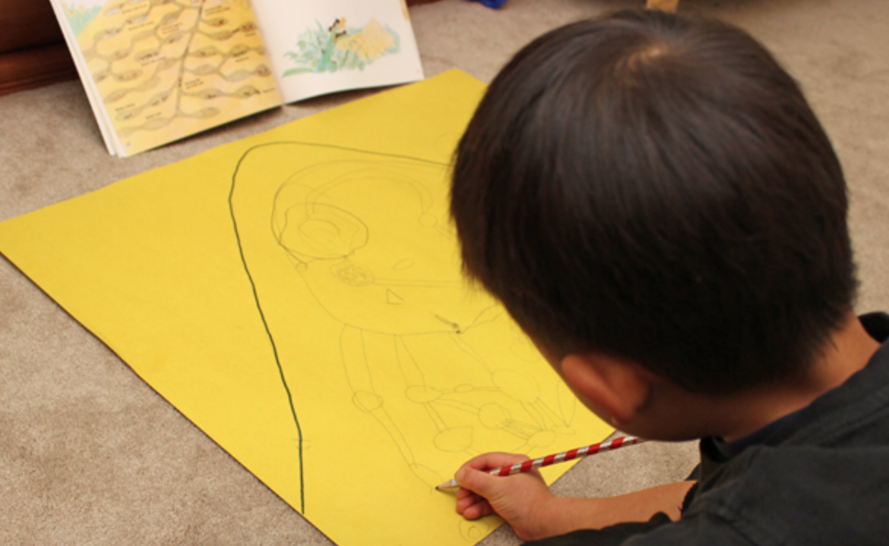
Read-A-Loud | Next to an Ant by Mara Rockliff-Learn what is tall next to an ant, a snail, a mouse, is tall or what is short.and even a shoe. It might be fun to find items at home that you can use to see what | https://www.youtube.com/watch?v=u9WQ7Qy1-ik&feature=share | 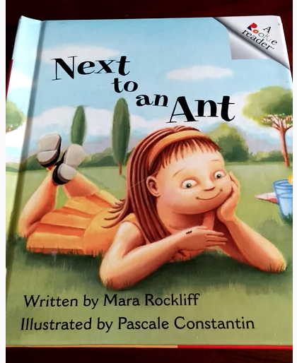
Literature | From Caterpillar to Butterfly, by Deborah Heiligman | https://www.youtube.com/watch?v=lItvNJ6YY98
Literature | A Butterfly Is Patient by Dianna Hutts Aston and Sylvia Long | https://www.youtube.com/watch?v=gOFW0Pk9uNY
Literature | Gott Go, Gott Go, by Sam Swope | https://www.youtube.com/watch?v=0mRbX090P-0
Literature | Clara Caterpillar | https://www.youtube.com/watch?v=smE11VNm3HA
Literature | The Very Lonely Firefly by Eric Carle | https://www.youtube.com/watch?v=_XrPyF4Mpl4&t=26s
Literature | The Very Quiet Cricket by Eric Carle | https://www.youtube.com/watch?v=YdiGEjz5b0Q&t=5s
Literature | Ladybug at Orchard Avenue | https://www.youtube.com/watch?v=iv73h58RWDg
Literature | How to Hide a Butterfly & Other Insects | https://www.youtube.com/watch?v=fafhKQvi9rY
Literature | Bug Hunt by Tom Story | https://www.youtube.com/watch?v=7nL7On2gBkw
Literacy | Letter Swat - Draw / write letters on paper or with chalk on the ground/floor. Use a fly swatter and “swat” the letters called out by an adult or sibling. | https://www.pinterest.com/pin/744360644649666157/ | 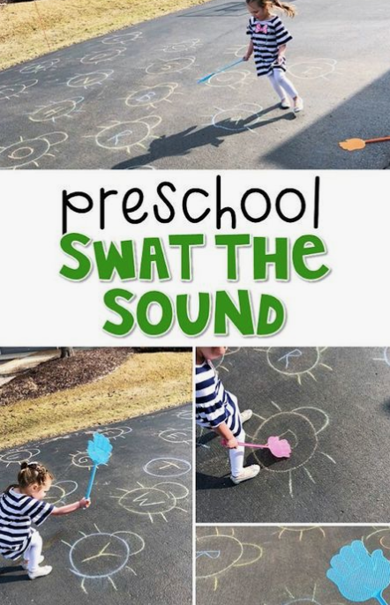
Mathematics | Bugs and Insects: Count and Clip Cards - Print and Use Clothespins to match the number of bugs and insects to the corresponding numeral. | Attached | 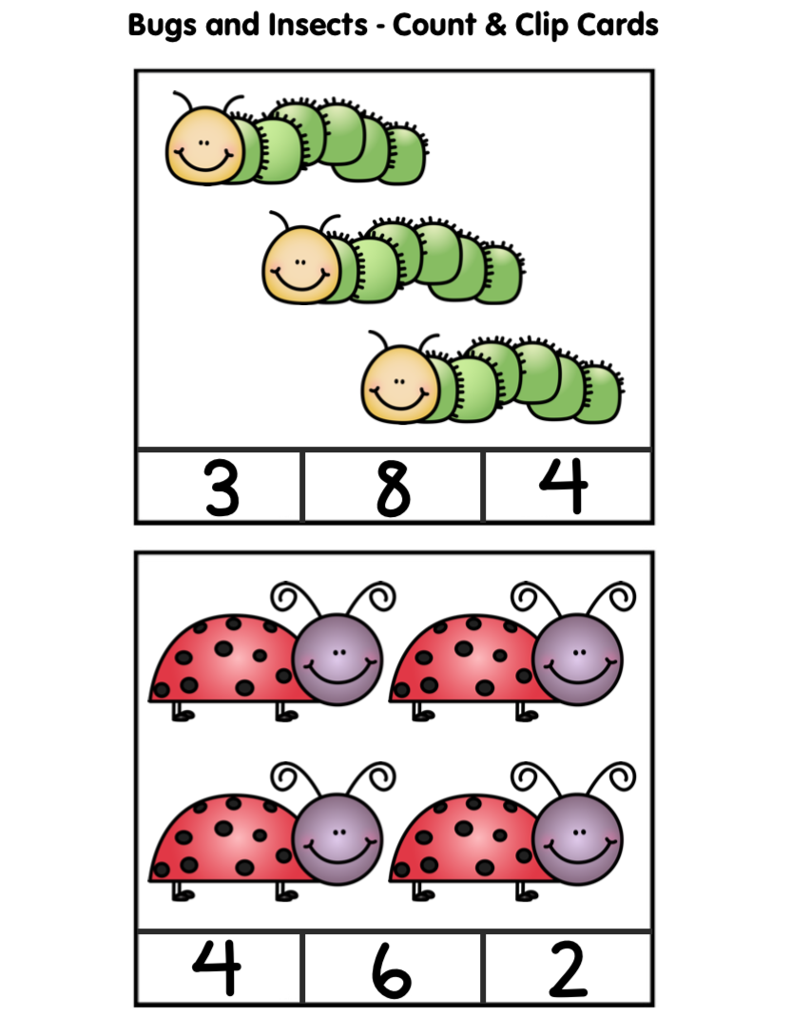
Science | Insects: Educational Video for Kids | https://www.youtube.com/watch?v=iJlfBNyBKQA | 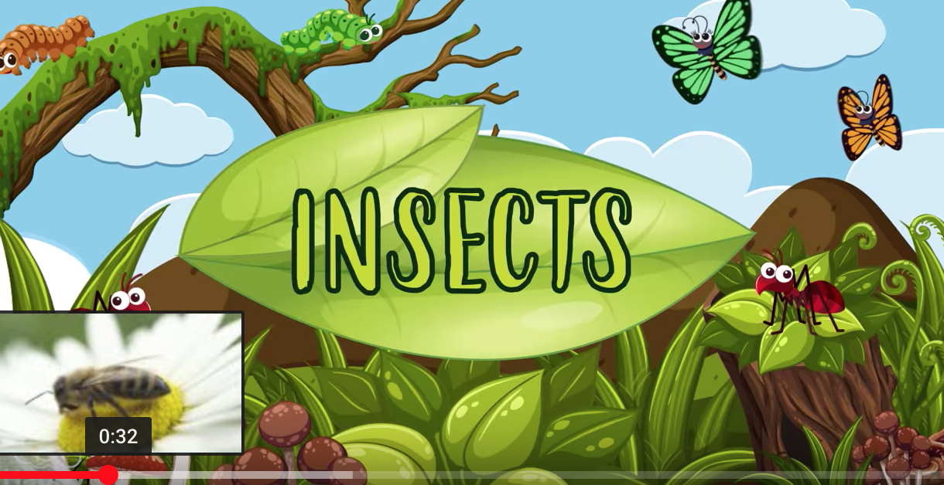
Science | Insects have three body parts: head, thorax abdomen; they have 6 legs, compound eyes and two antennae. You can sing this song to "Head, Shoulders, Knees and Toes." "Head, Thorax Abodomen, Abdomen; Head, Thorax, Abdomen, Abdomen; Compound eyes, Six legs and Two antennae; Head, thorax Abdomen, Abdomen." If you go on a bug hunt and find a creepy-crawly, count the legs and body parts to determine if it is a spider (2 body parts, 8 legs) or an insect. | https://i.pinimg.com/564x/8e/54/d5/8e54d50269fa322ed3885f90a8c1a7c0.jpg | 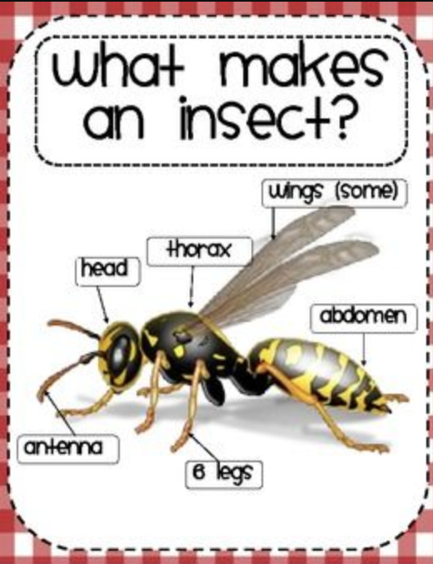
Nature/Science | Spend time outside creating a Roly Poly Habitat | https://www.fantasticfunandlearning.com/make-roly-poly-habitat-kids.html?utm_content=buffer6f5d7&utm_medium=social&utm_source=pinterest.com&utm_campaign=buffer | 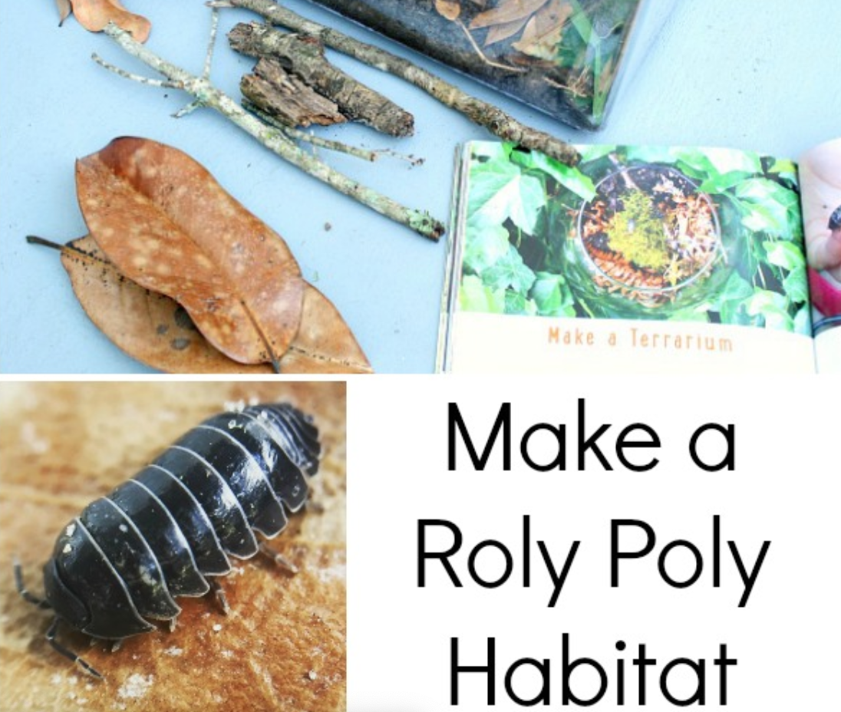
Nature/Science | Nature Art Insects - Find leaves and objects outside to put together for form insects, including part: Head, Thorax, Abdomen, and Antennae | https://www.pinterest.com/pin/206813807876572121/ | 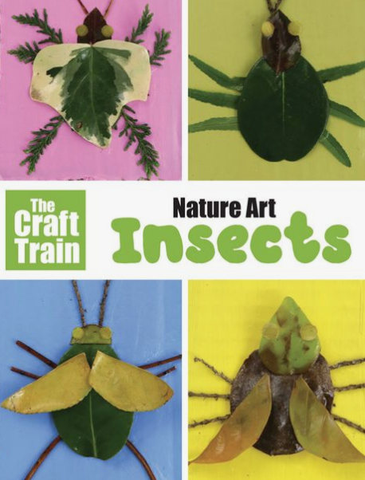
Music | 5 Hungry Ants-Enjoy counting down to this fun song about ants at a picnic. | https://youtu.be/zoyTo_ICWj0 | 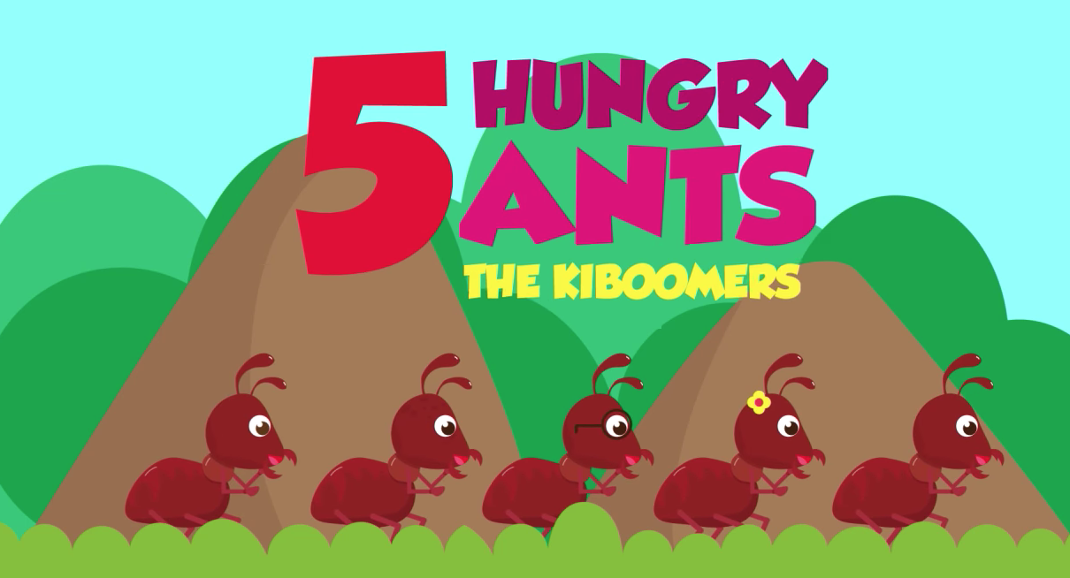
Music | “Fireflies” Song by Laurie Berkner | https://www.pinterest.com/pin/119345458854995539/ | 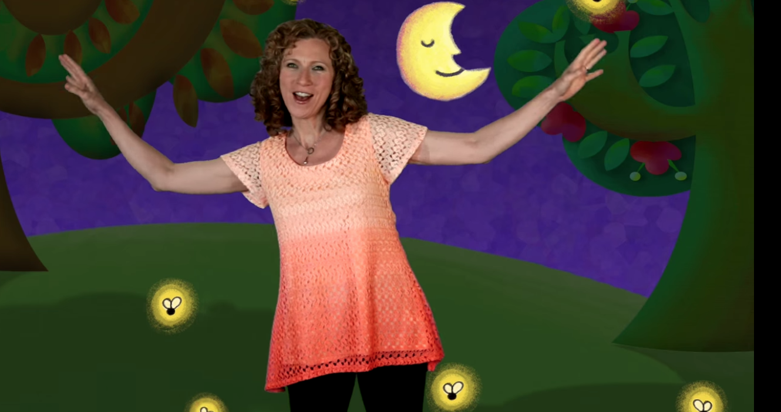
Music | “All Around My Yard” to the tune of “Wheels on the Bus” | Attached
FINGER PLAY | 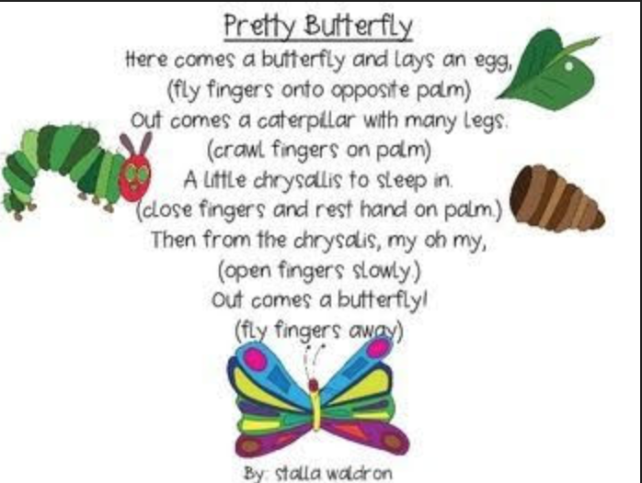 | Attached
Art | Painting Butterfly Wings / Symmetry | https://www.pinterest.com/pin/744360644649958730/ | 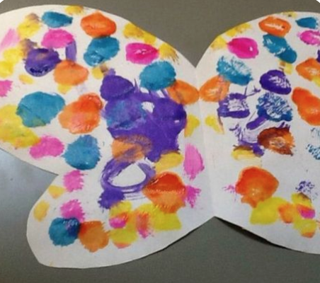
Art | Potato Ladybug Stamp | https://www.pinterest.com/pin/AWWJDYOw6AoGAJFvYXka1v96KA67sHp2dqUfpjXFJVC47p0ibzl3c_o/ | 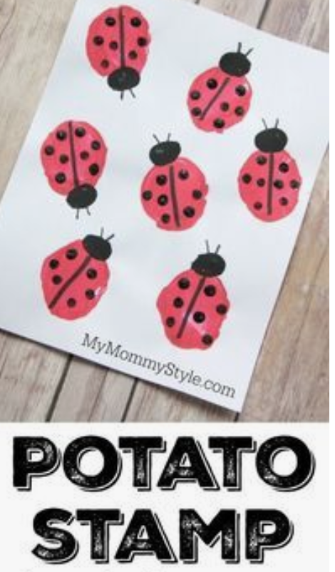
Art/Math | Create a Honey Comb | https://www.123homeschool4me.com/honeycomb-craft_55 | 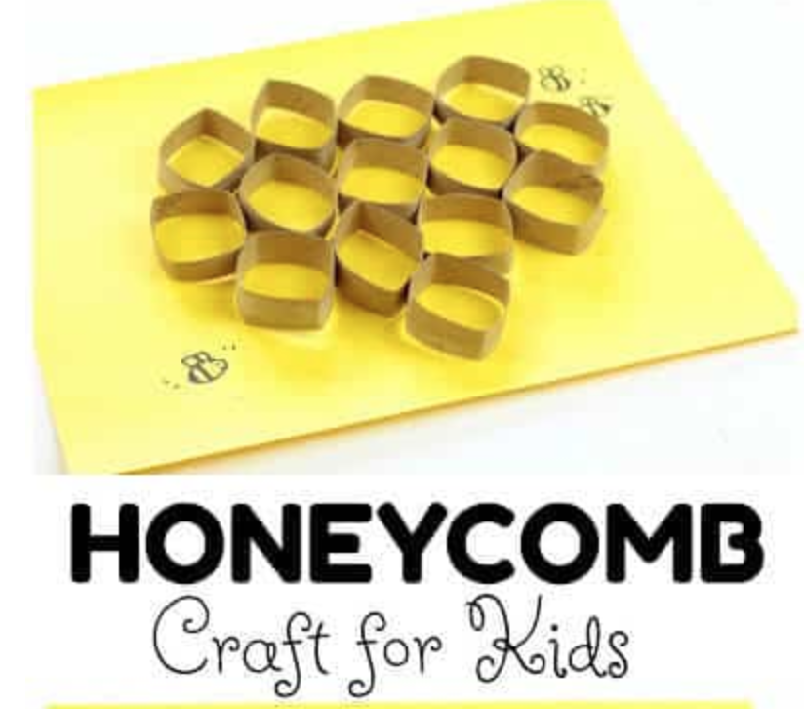
Art | Bug Prints | https://www.pinterest.com/pin/206813807876572123/ | 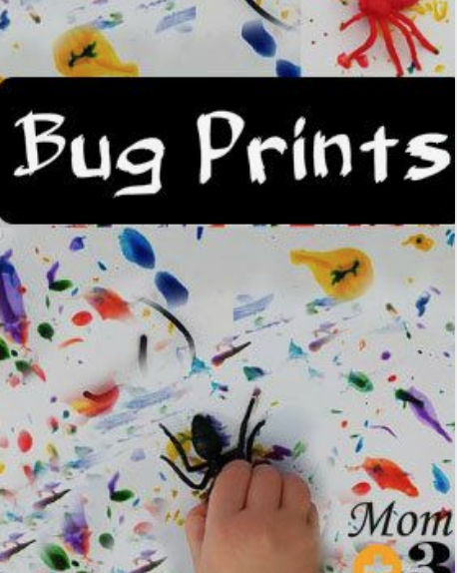
Art | Eric Carle Insects | https://www.pinterest.com/pin/206813807876572115/ | 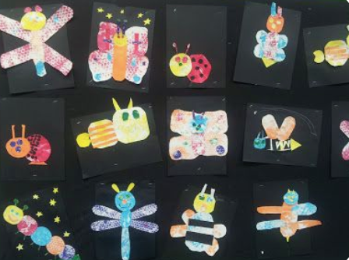
French | Using the Very Busy Spider by Eric Carle (in English) access the youtube link for the French version. I usually read one page in French followed by the same page in English. | https://www.youtube.com/watch?v=z1bNjhCv9OI&list=PL83Qz6QDA-nYrYpHZumhhWbSaT3XDy0AO&index=3 | 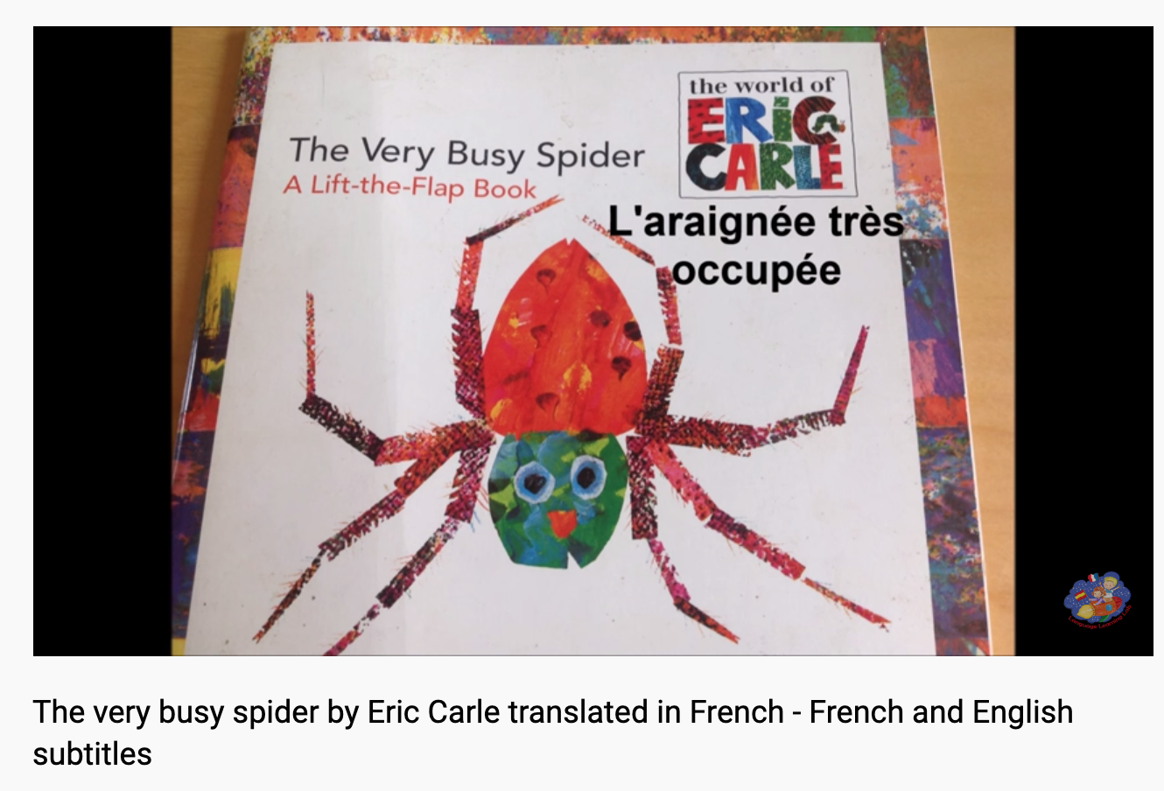
Gross Motor | Use the attached Action Cards. You can cut the pictures into flash cards and ask the children to "Fly like a ladybug." etc. | Attached
Gross Motor | Bug Hop - Draw pictures of insects (three body parts, six legs) on sidewalk or driveway. Hop from insect to to insect. Now skip around them, in and out. Add other movements (gallop, crawl) | Attached
Gross Motor | Print the attached MOVEMENT DICE. Roll and make the movement of the insects. | Attached | 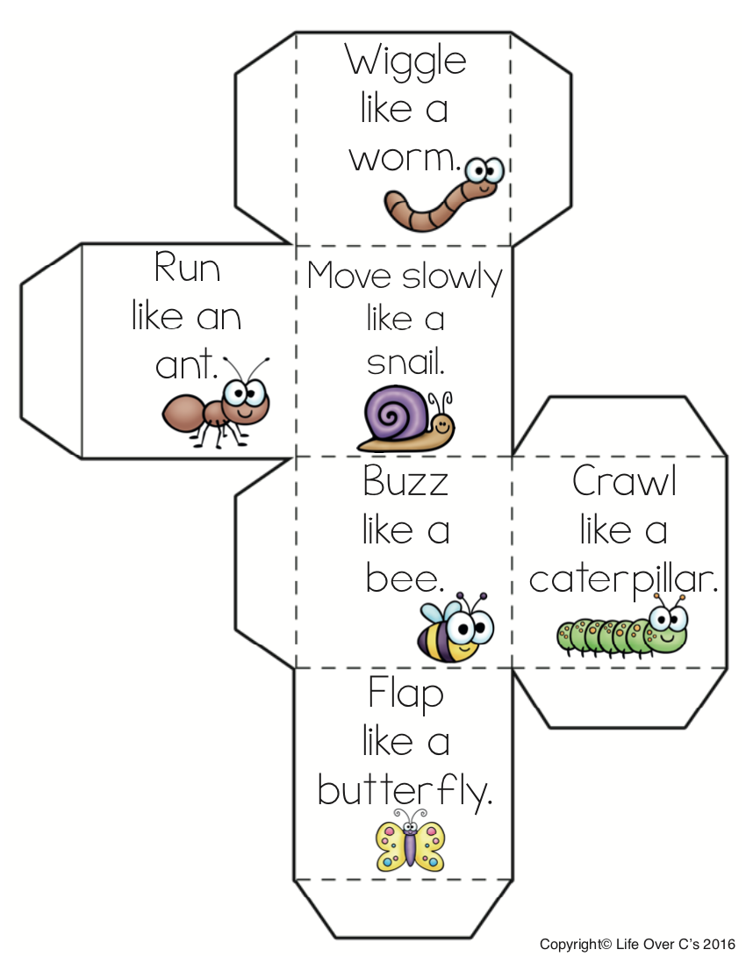
Gross Motor | Mosquito Tag: Play mosquito tag! The person who is “it” has a supply of small, inexpensive stickers (check the dollar store). He/she tries to tag the other players by placing a small sticker (dot stickers would be fun!) on them as a “mosquito bite.”
Fine Motor | Bug and Insect Play Dough Fossils | https://www.pinterest.com/pin/AULpVtOfxVJ6EChjAvXVbybMVz2-yZdJqeAB4n99H-XuqtHkQUVe9NM/ | 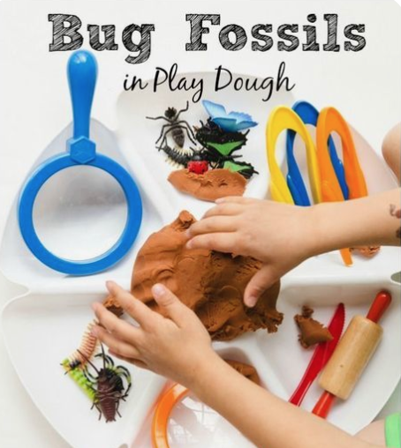
Fine Motor | Play Dough Insects | https://www.pinterest.com/pin/206813807876572120/ | 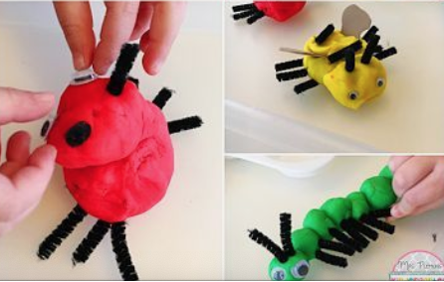

Week of April 6th - 10th
Insects

